2405401

**Website Storyboard Document**

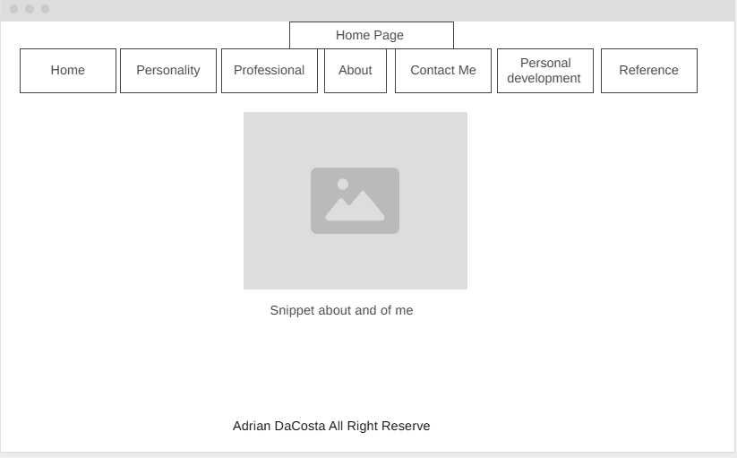Home Page

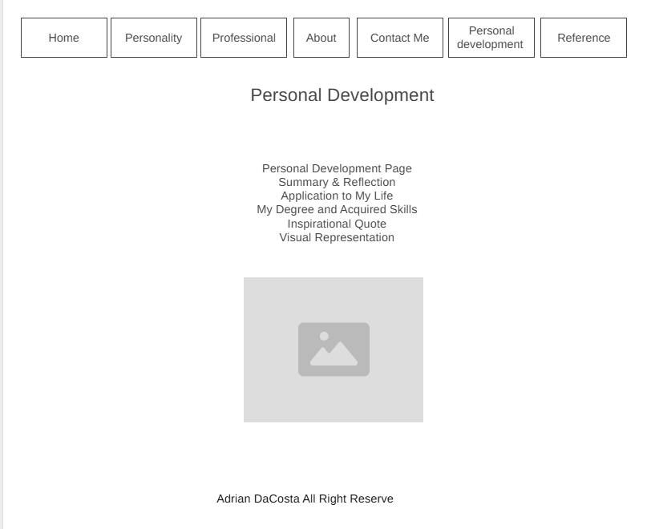Personal Development 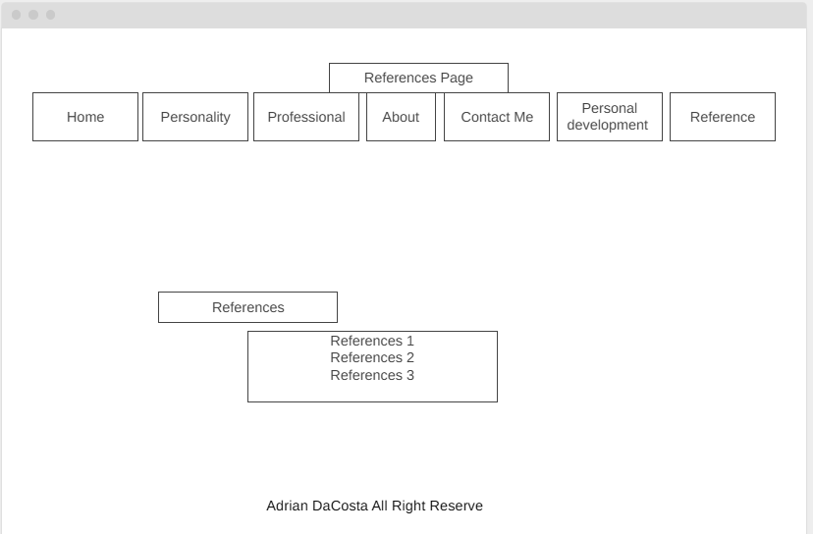

**Contact Me**

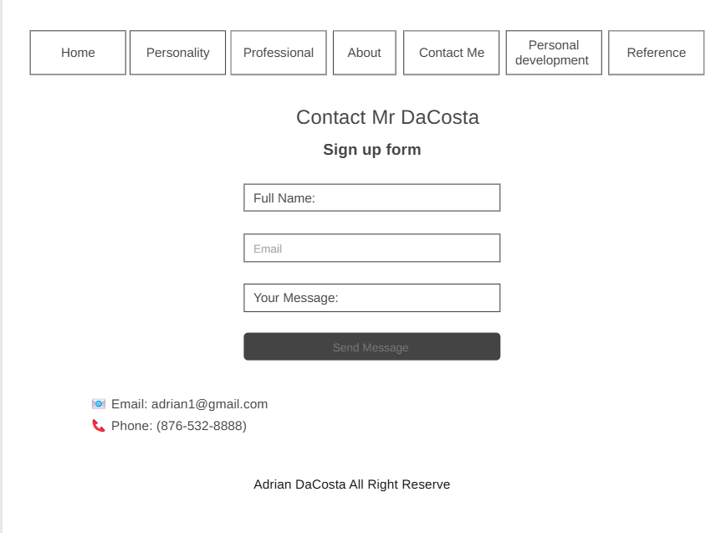

About Me

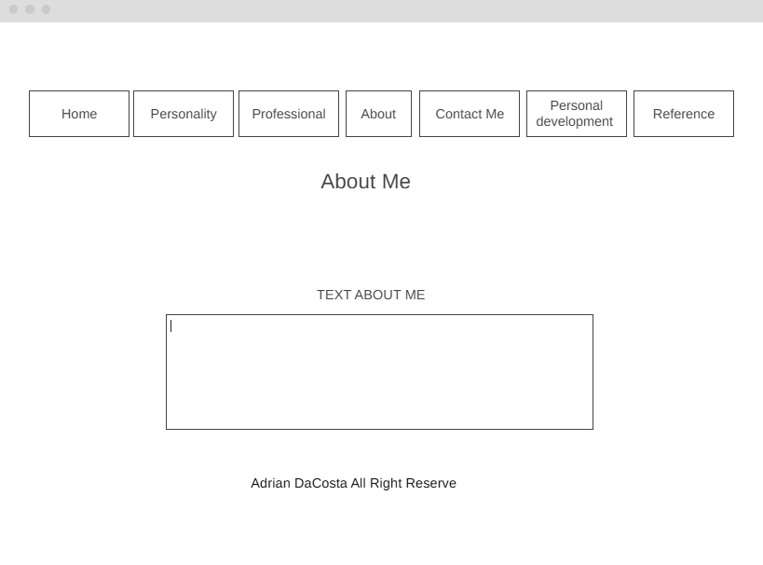

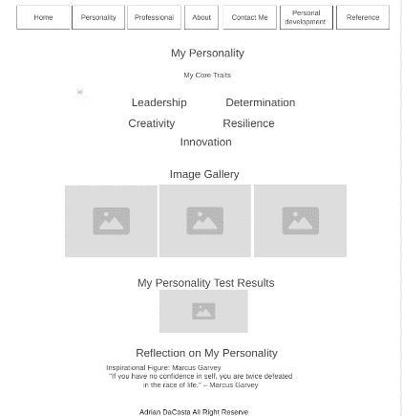My Personality

Reference

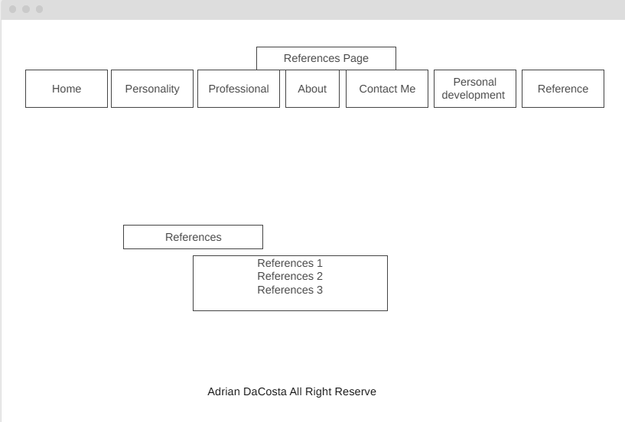

Personal Development Page

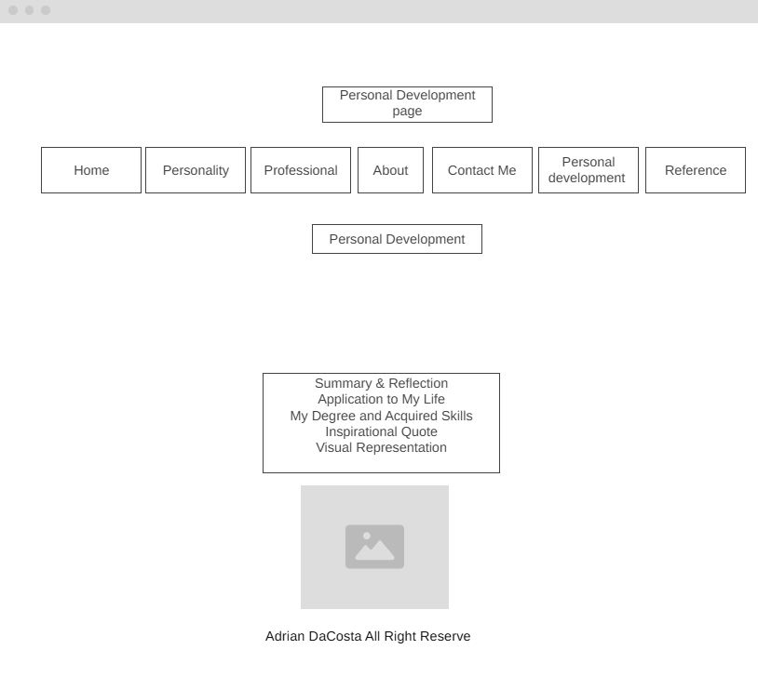

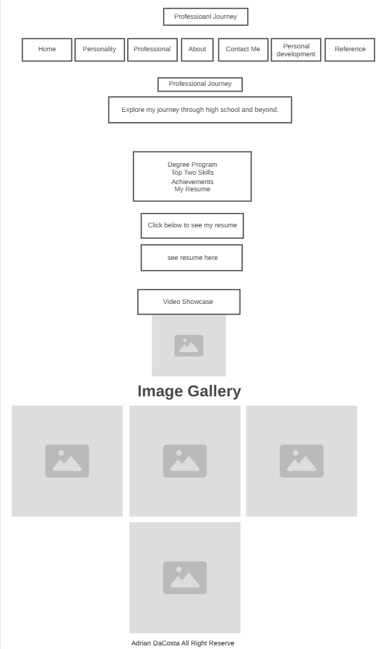Professional

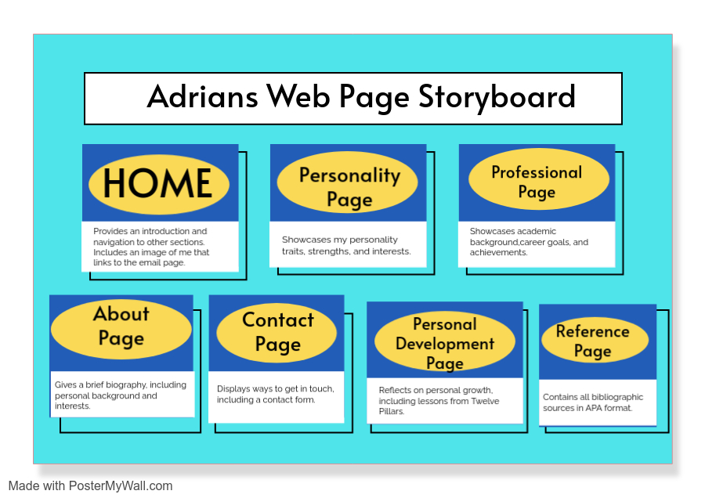

**Wireframe / Layout Design (6 marks)**

[Insert wireframe images here]

Label each wireframe accordingly:

* Home Page Wireframe
* Professional Page Wireframe
* Personality Page Wireframe
* Personal Development Page Wireframe
* Reference Page Wireframe

**2. List of Web Pages & Purpose (6 marks)**

* **Home Page:** Introduction and navigation.
* **Professional Page:** Showcases work experience, education, and professional skills.
* **Personality Page:** Highlights personal interests, hobbies, and character traits.
* **Personal Development Page:** Summarizes learnings and reflections from *Twelve Pillars* by Jim Rohn & Chris Widener.
* **Reference Page:** Lists sources used for research and information, formatted in APA style.

**3. Theme of the Site (3 marks)**

* **Color Palette:** Blue & white (or chosen theme).
* **Font Style:** Arial, sans-serif (or chosen font).
* **Target Audience:** Students, teachers, and potential employers.

**4. List of Features (5 marks)**

The website includes the following features:

* **Image Gallery** to visually showcase experiences.
* **Navigation Menu** for easy access to different pages.
* **External Links** to relevant sources and references.
* **CSS Styling** for a modern and user-friendly design.
* **Hover Effects** for interactive elements.